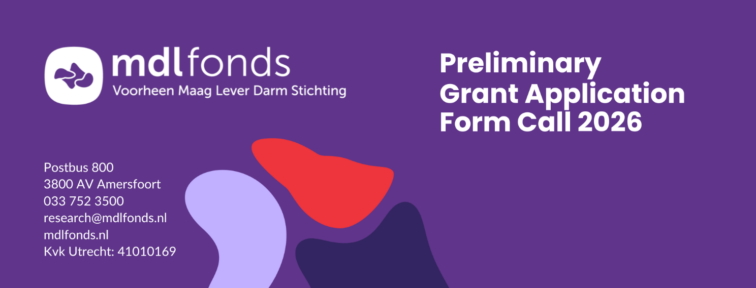
Projectnumber: *
* will be assigned by the MDL Fonds
Please refer to the ‘Manual Preliminary Grant Application 2026’ for instructions.
Attention: Please note that this form must be submitted via our online grant portal in Word format. Only pre-application forms received through the portal will be taken into consideration.

General information
1 | Title of the Project
1 | Dutch summary  (max. 200 words)
2 | Institute
2 | Department
2 | Address
3 | Project Leader | First name, last name and title(s); ☐Mr./ ☐Mrs./ ☐Other ……………………………………………………………………………………….  Please specify your position at the apply institute: ……………………………………………………………………………………….  Do you have a permanent position? If not, when does your contract ends? ..............................................................................................................
3 | Telephone
3 | E-mail
4 | Project group
  Name, academic title | Discipline | Employed by | Time spent (% fte) and the role /contribution to this project
  Patient (representative) or Patient Association
5 | Research specifications
 | Type of research | ☐ Clinical  ☐ Translational
 | Theme of research | ☐ Gastrointestinal oncology  ☐ Acute gastrointestinal diseases  ☐ Chronic gastrointestinal diseases
 | Specification GI disease | ☐ Acute pancreatitis  ☐ Acute Intestinal Ischemia  ☐ Auto-immune hepatitis  ☐ Coeliac disease  ☐ Chronic pancreatitis  ☐ Chronic hepatitis  ☐ Cholangitis | ☐ Cholecystitis  ☐ Colon cancer  ☐ Hepatitis  ☐ Functional disorders  ☐ Hepatitis  ☐ IBD  ☐ IBS | ☐ Liver cancer (HCC)  ☐ MASLD  ☐ Motility disorders  ☐ NEC  ☐ Pancreatic cancer  ☐ Portal hypertension  ☐ Other:…
 | Key points | ☐ Pediatric research  ☐ Appropriate care (’less is more’)  ☐ Unmet medical need  ☐ Patient-centered outcomes  ☐ Lifestyle
 | Follow-up research | Is the research further development and/or implementation of promising project results, from research already funded by MDL Fonds? Please indicate the previous project code: ……………………………………………………………
 | Alignment with existing knowledge agenda’s  (if applicable) | Name of knowledge agenda: ……………………………………………………………  Link to knowledge agenda: ……………………………………………………………  Reference paragraph/ page: ……………………………………………………………  ☐ Not applicable
 | Duration of research
6 | Budget
 | Personnel costs
  Type | FTE | Duration of appointment | €
  PhD student (non-MD) |  |  | €
  PhD student (MD) |  |  | €
  Post doc |  |  | €
  Supporting Non Academic personnel |  |  | €
  Patient and/or patient organization |  |  | €
  Other, … |  |  | €
  Total personnel costs |  |  | €
 | Equipment costs
  Type | Specification | €
  Materials |  | €
  Animals |  | €
  Other, … |  | €
  Total Equipment costs |  | €
 | Total project costs | €
 | Amount covered by MDL Fonds grant | €
 | Co-financing | ☐ Applicable ☐ Not applicable
 | Financial Coverage
  Partner(s) | Amount (€) | Allocated (yes/no, decision expected mm/yyyy) | Description
   | €
   | €
   | €
   | €
   | €
   | €
 | Description financial coverage
 | Role MDL Fonds
7 | Signatures
7 | Project leader Date (dd/mm/yyyy)
7 | Name:  Signature:
7 | Participants of project group
7 | Name:  Signature: |  | Name:  Signature:
7 | Name:  Signature: |  | Name:  Signature:
7 | Name:  Signature: |  | Name:  Signature:
7 | Name:  Signature: |  | Name:  Signature:
7 | Head of department/ institute Date (dd/mm/yyyy)
7 | Name:  Function:  Signature:

Project summary (English, max 1400 words)
Do not exceed the maximum of 1400 words excluding five relevant publications.
8 | Title | English:  Dutch:
9 | Background
10 | Hypothesis
11 | Objective
12 | Relevance (for the patients/end users)
13 | Patient participation (during design and execution of the project)  Min. of 100 words
14 | Methods
14 | Study design
14 | Study population | Inclusion criteria:  Exclusion criteria:  Sample size calculation:  Data collection:
14 | Samples (if applicable) | Origin:  Type:  Amount:  Availability:  Feasibility of the envisaged research sample:
14 | Analysis | Statistical method:  Study parameters/endpoints:  Methods/intervention:  Machine/software:
14 | Work plan (including timeframe and milestones)
15 | Anticipated results
16 | Knowledge utilization
17 | Five relevant publications concerning this application | 1)  2)  3)  4)  5)

